

MS Word Training – Session 2: Part 1

Bullets & Numbering & Hyperlink Concepts
Version: 1.0
February, 2009
Copyright Information:
This document is the sole property of AIG Inc. All rights reserved. No part of this document may be reproduced, stored in a retrieval system, translated, transcribed, or transmitted in any form or by any means, without the prior written permission of AIG Systems Solutions (AIGSS).
Document Information
S.No | Document Title | Base Version No. | Author | Contact Email ID | Date Of Release
1 | MS Word Session 2: Part 1 | 1.0 | Deepika Datta | deepika.datta@aig.com | February 2009
Revision History
S.No | Version No. | Date Of Release | Author (s) | Affected Section(s) | History of Changes | Approver

Table of Contents
1 Bullets & Numbering 4
1.1 Bullets and Numbers 4
1.1.1 Working with an existing list 4
1.1.2 Starting a new list 4
1.1.3 Turning off numbers/bullets 4
1.1.4 Modifying numbers/bullets 4
1.1.5 Automatic numbers/bullets 4
2 Hyperlinks 5
2.1 Create a hyperlink 5
2.1.1 Linking to an existing file or Web page 5
2.1.2 Linking to a file you haven't created yet 5
2.1.3 Linking to an e-mail address 6
2.1.4 Linking to a specific location in another document or Web page 6
2.1.5 Linking to a specific location in the current document or Web page 6
2.1.6 Linking to another file or program that you drag from 7
2.2 Changing a hyperlink 7
2.2.1 Change the hyperlink destination 7
2.2.2 Change the display text of a hyperlink 8
2.3 Formatting hyperlinks 8
2.3.1 Format a hyperlink 8
2.3.2 Format all hyperlinks in a document 8

Bullets & Numbering

Bullets and Numbers
You can easily number lists, or apply bullet points using the Numbering 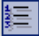 or Bullets  buttons on the Formatting toolbar.
- This is the first item on a numbered list.
- This is the second.
  - This is the first item on a bulleted list.
  - This is the second.

Working with an existing list
- For lists items which need to begin with number other than 1, right-click on the list, select Bullets and Numbering and click the Customize tab to predefine the list.
- To restart the numbering of an existing list, right-click on the list, select Restart Numbering.

Starting a new list
- Click where you wish to start the list.
- Click on the Numbering or Bullets button as appropriate.
- Numbers or bullets will now appear as you type each paragraph.

Turning off numbers/bullets
You may turn off numbering or bulleting by clicking on the Numbering/Bullet button, or by pressing Enter twice at the end of a list.

Modifying numbers/bullets
You can use the options on the Format menu → Bullets and Numbering submenu to change the appearance of your numbers and bullets.

Automatic numbers/bullets
Word facilitates shortcut to generating automatic numbering or bullet lists.
- You can create a numbered list if you type the number 1 followed by a space or tab, followed by some text and press Enter. The number 2 will appear automatically on the next line.
- You can create automatic bullet points by typing * followed by a space or Tab followed by some text. Again, when you press Enter your text will be bulleted automatically.
Note: While the above given illustration is for manual formatting, it is recommended that for more stable numbering in voluminous documentation, one must adhere to the following formatting rules:
- Use the recommended List styles for numbering and bullets.
- Manage numbering controls through numbering property of the applied style.
- For sequential numbering controls defined at levels such as Heading 1, Heading 2 and Heading 3, ensure that numbering is defined appropriately in the Outlined numbered tab of Heading 1 style.

Hyperlinks
Word creates a hyperlink for you when you type the address of an existing Web page.
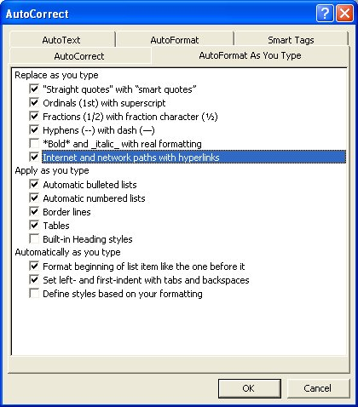
You can turn this feature off if you wish as follows:
- From the Tools menu select AutoCorrect Options.
- Select the AutoFormat As You Type tab.
- Click on the tick next to Internet and network paths with hyperlinks to remove it.
- Click OK to save your change and close the dialog box.
Convert a hyperlink to regular text
To change a hyperlink back into normal text, right-click the hyperlink and then click Remove Hyperlink.

Create a hyperlink
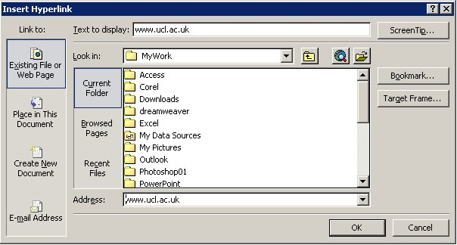
If the automatic formatting of hyperlinks has been turned off, you can create customized links to an existing or new document, file, or Web page.
- Select the text or picture you want to display as the hyperlink.
- Click Insert Hyperlink on the Standard toolbar/ Right click on the selected area and select Hyperlink from the shortcut menu/ Press Ctrl+K.

Linking to an existing file or Web page
- Under Link to, click Existing File or Web Page.
- In the Look in box, click the down arrow, and navigate to and select the file or, in the Address box, or type the address you want to link to.
- Click OK. The selected text will become a hyperlink to the specified file or web page.

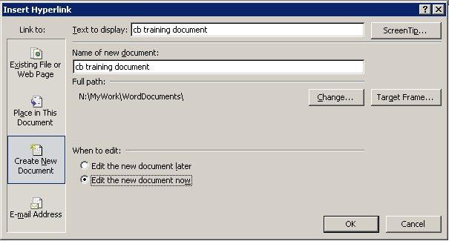
Linking to a file you haven't created yet
- Under Link to, click Create New Document.
- In the Name of new document box, type the name of the new file.
- Check the location of the new file. If necessary, click on the Change button to specify which folder you want to save your new document to.
- If you want the Hyperlink to display text that is different to the file name, type the relevant text into the Text to Display box.
- Under when to edit:, click either Edit the new document later or Edit the new document now.
- Click OK.

Linking to an e-mail address
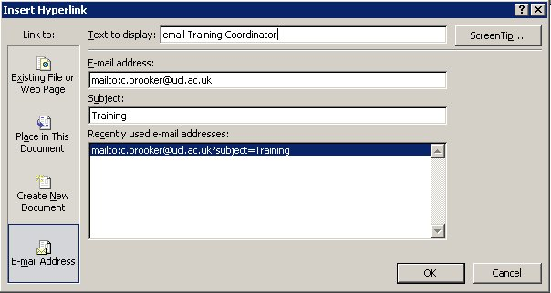
- Display the Insert Hyperlink dialog box.
- Under Link to, click E-mail Address.
- Either type the e-mail address you want in the E-mail address box, or select an e-mail address in the Recently used e-mail addresses: box.
- In the Subject box, type the subject of the e-mail message. (This is optional – if you enter a subject, it will be automatically entered in the subject field when anyone uses the hyperlink to create an e-mail message.)
- If you want the hyperlink to display text that is different to the e-mail address, type the relevant text into the Text to Display box.
- Click OK. The e-mail address, or whatever you keyed into the Text to Display box, will be inserted into your document.
When the hyperlink is activated, the default e-mailer will be displayed with a new e-mail addressed to the specified addressee.

Linking to a specific location in another document or Web page
- Insert a bookmark in the destination file or Web page.
- Open the file that you want to link from, and select the text or object you want to display as the hyperlink.
- Display the Insert Hyperlink dialog box.
- Under Link to, click Existing File or Web Page.
- In the Look in box, click the down arrow, and navigate to and select (single click - do not double click the filename) the file that you want to link to.
- Click the Bookmark button.
- Select the bookmark you want, and then click OK.
Note:
From Word documents, you can create links to specific locations in files that are saved in Excel (.xls) or PowerPoint (.ppt) format. To link to a specific location in an Excel workbook, create a defined name in the workbook, and then at the end of the file name in the hyperlink, type # (number sign) followed by the defined name. To link to a specific slide in a PowerPoint presentation, type # followed by the slide number after the file name.

Linking to a specific location in the current document or Web page
- To link to a place in the current document, you can use either heading styles or bookmarks in Word.
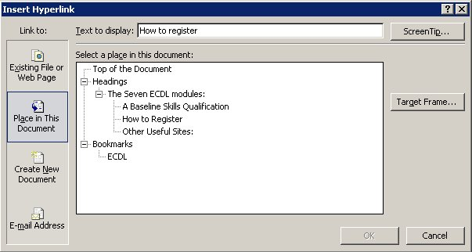
- In the current document, do one of the following:
- Apply one of Word's built-in heading styles to the text at the location you want to go to.
- Insert a bookmark at the location you want to go to.
- Select the text or object you want to display as the hyperlink.
- Display the Insert Hyperlink dialog box.
- Under Link to, click Place in This Document.
- In the list, select the heading or bookmark you want to link to.
- Click OK.

Linking to another file or program that you drag from
You can create a hyperlink quickly by dragging selected text or pictures from a Word document or PowerPoint slide, a selected range in Excel, a selected database object in Access, or a Web address or hyperlink from some Web browsers.
The text you copy must come from a file that has already been saved.
- Display both files on the screen.
- If you are dragging text between two Word files, open both files, and then click Arrange All on the Window menu. If you are dragging text between two programs, resize the windows of both programs so you can see them at the same time.
- In the destination document or worksheet, select the text, graphic, or other item you want to jump to.
- Right-click and drag the selection to the document where you want to create the hyperlink
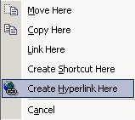
- As you drag the selection into your document, a shortcut menu appears.
- Click Create Hyperlink Here.
Note:
You can also copy and paste text as a hyperlink to achieve the same effect. Copy the text you want to the Clipboard, click where you want to insert the text, and then click Paste as Hyperlink on the Edit menu.
You cannot drag and drop drawing objects, such as AutoShapes, to create hyperlinks. To create a hyperlink for a drawing object, select the object and then click Insert Hyperlink on the Standard toolbar.
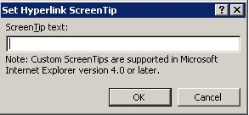
Screen tips
To display a ScreenTip when you rest the mouse over the hyperlink:
- Click the ScreenTip button from the top right of any Hyperlink dialog box.
- In the Set Hyperlink Screen Tip dialog box, type the text you want displayed.
- Click OK.
- For links to headings, Word uses "Current document" as the tip if you do not specify one.
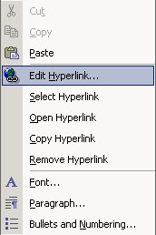
- For links to bookmarks, Word uses the bookmark name.

Changing a hyperlink

Change the hyperlink destination
- Right-click the hyperlink you want to change, and then click Edit Hyperlink.
- In the address box, enter a new destination address for the hyperlink.
- Click OK.

Change the display text of a hyperlink
- Select the hyperlinked text.
- Type the new text. (Do not type any spaces.)
- The new text will become the hyperlink.
Note:
You can also right-click the hyperlink, click Edit Hyperlink, and then type new text into the Text to display box.

Formatting hyperlinks

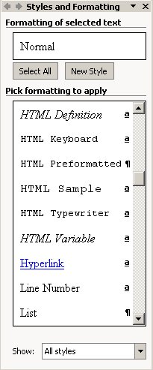
Format a hyperlink
You can format text or a graphic that is displayed for a single hyperlink by selecting the text or graphic and applying new formatting.

Format all hyperlinks in a document
Change the appearance of all text hyperlinks in a document as follows:
- Open the document that contains the hyperlinks you want to change.
- On the Formatting toolbar, click Styles and Formatting,
or select Styles and Formatting from the Format menu.
- The Task Pane will display a list of styles. If necessary, select All Styles in the Show box at the bottom of the Task Pane.
- To change the appearance of hyperlinks, in the Pick formatting to apply box, right-click the Hyperlink style, and then click Modify.
- Select the formatting options that you want, or click Format, and then click Font to see more options.
- Click OK to close the dialog boxes.

